Dryden Regional Health Centre
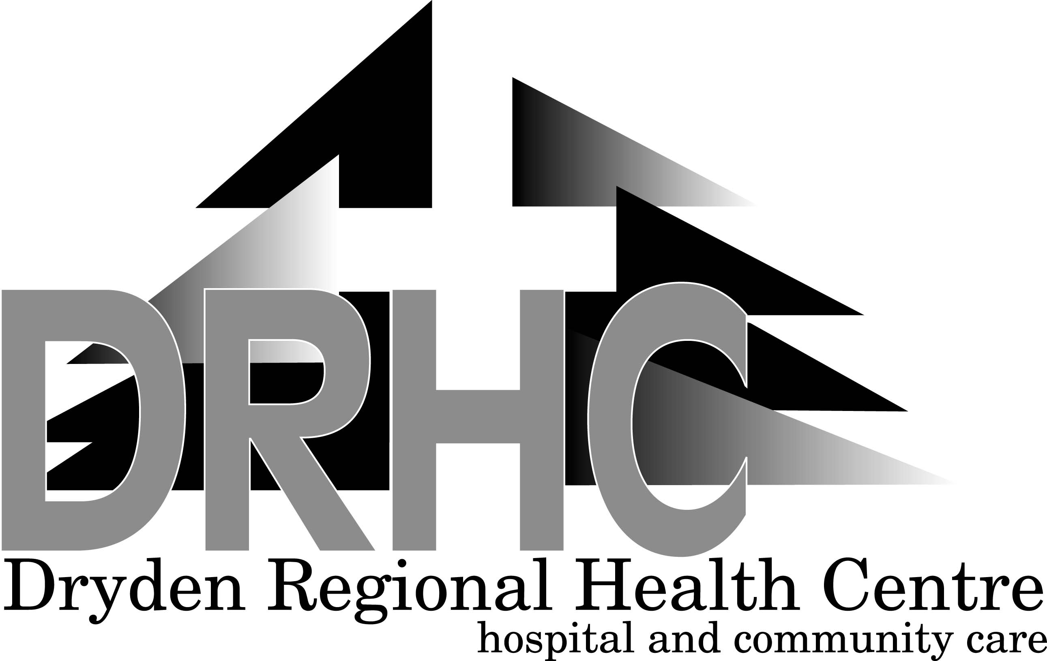
58 Goodall Street, P.O. Box 3003, Dryden, Ontario P8N 2Z6
Telephone (807)223-8200 Main Fax (807)223-2370
Administration Fax (807)223-8628

DOUG ROBINSON Wade Petranik
Chair, Board of Directors Chief Executive Officer

Reference Check Release Form

I hereby authorize representatives of the Dryden Regional Health Centre to contact my previous employers and references as supplied on my resume. The Dryden Regional Health Centre may obtain information concerning my past employment history, performance and/or any other information relevant to my employment at the Dryden Regional Health Centre.

I hereby declare that the information I have provided in my interview and on my resume is accurate. I recognize that knowingly supplying false information will be grounds for immediate disqualification from consideration for employment with the Dryden Regional Health Centre, and would be grounds for termination with cause.

I understand that consideration for employment with the Dryden Regional Health Centre is contingent on the collection of satisfactory references.

Applicant Name (please print):

Signature: __________________________________________________

Date: __________________________________________________

